H.T No
Regulations:
A22

Sreenidhi Institute of Science and Technology
(An Autonomous Institution)
Code No:9K405 Date: 08-July-2025 (FN)

B.Tech II-Year II- Semester External Examination, July-2025 (Regular and Supplementary)
STRENGTH OF MATERIALS-II (CIVIL)

Time: 3 Hours Max.Marks:60

Note: a) No additional answer sheets will be provided.
b) All sub-parts of a question must be answered at one place only, otherwise it will not be valued.
c) Missing data can be assumed suitably.
Bloom's Cognitive Levels of Learning (BCLL)

Remember | L1 | Apply | L3 | Evaluate | L5
Understand | L2 | Analyze | L4 | Create | L6

Part - A Max.Marks: 6x2=12

Answer all QUESTIONS, EACH QUESTION CARRIES 2 MARKS.

 |  | BCLL | CO(s) | Marks
1 | Define Torsional rigidity | L1 | CO1 | [2M]
2 | Write the assumptions of EULER'S Theory | L1 | CO2 | [2M]
3 | Mention Various types of spring and also write the uses of springs. | L1 | CO3 | [2M]
4 | Define Direct stress and Bending Stress | L1 | CO4 | [2M]
5 | Define Thin Cylinder and Name the stresses set up in a thin cylinder subjected to Internal fluid Pressure | L1 | CO5 | [2M]
6 | Differentiate Unsymmetrical and Symmetrical Bending | L2 | CO6 | [2M]

Part – B Max.Marks: 6x8=48
ANSWER ALL QUESTIONS. EACH QUESTION CARRIES 8 MARKS.

 |  | BCLL | CO(s) | Marks
7. | Two shafts of same material and same length are subjected to same Torque. If the first shaft is of a solid circular section and second shaft is of a hallow circular section, whose internal diameter is 2/3 of external diameter and maximum shear stress developed in each shaft is same compare the weights of two shafts. | L3 | CO1 | [8M]
 | OR
8 | A solid circular shaft Transmit the 75 KW power at 200 RPM. Calculate the shaft diameter, if the twist in the shaft is not exceeded 1⁰ in 2 meters length of shaft and shear stress is limited to 50 Mn/m² and Shear Modulus is 100 GN/m² | L4 | CO1 | [8M]
9. | Derive Euler's formula for a column with both ends hinged. | L3 | CO2 | [8M]
 | OR
10 | From the following data, determine the thickness of cast iron column. Length of Iron column = 6Meters, External diameter= 200mm, load = 500 kN, Factor of safety = 6. Assume column both ends are fixed and ultimate compressive stress is 570 MN/m² and a = 1/1600 | L5 | CO2 | [8M]
11 | a) Draw neat sketches to illustrate the differences between a helical tension spring and a helical compression spring  b) A Helical coil spring made of round steel wire of 6.35mm in diameter. The mean radius of Helix is 31.75mm, number of complete turns 12, the spring is closely coiled if Modulus of rigidity is 84.36 GN/m² | L4 | CO3 | [8M]
 | OR
12 | A close coiled Helical spring of 100 mm mean diameter is made of 10 mm diameter rod and has 20 turns. The spring carries an axial load of 200N. Determine the shearing stress. Taking the values of modulus of rigidity = 84 GN/m² Determine the deflection when carrying the load and also calculate the stiffness of spring. | L5 | CO3 | [8M]
13 | A masonry Pier of 3m*4m supports a load of 40 kN as shown in below figure. Find out stresses each corner of pier  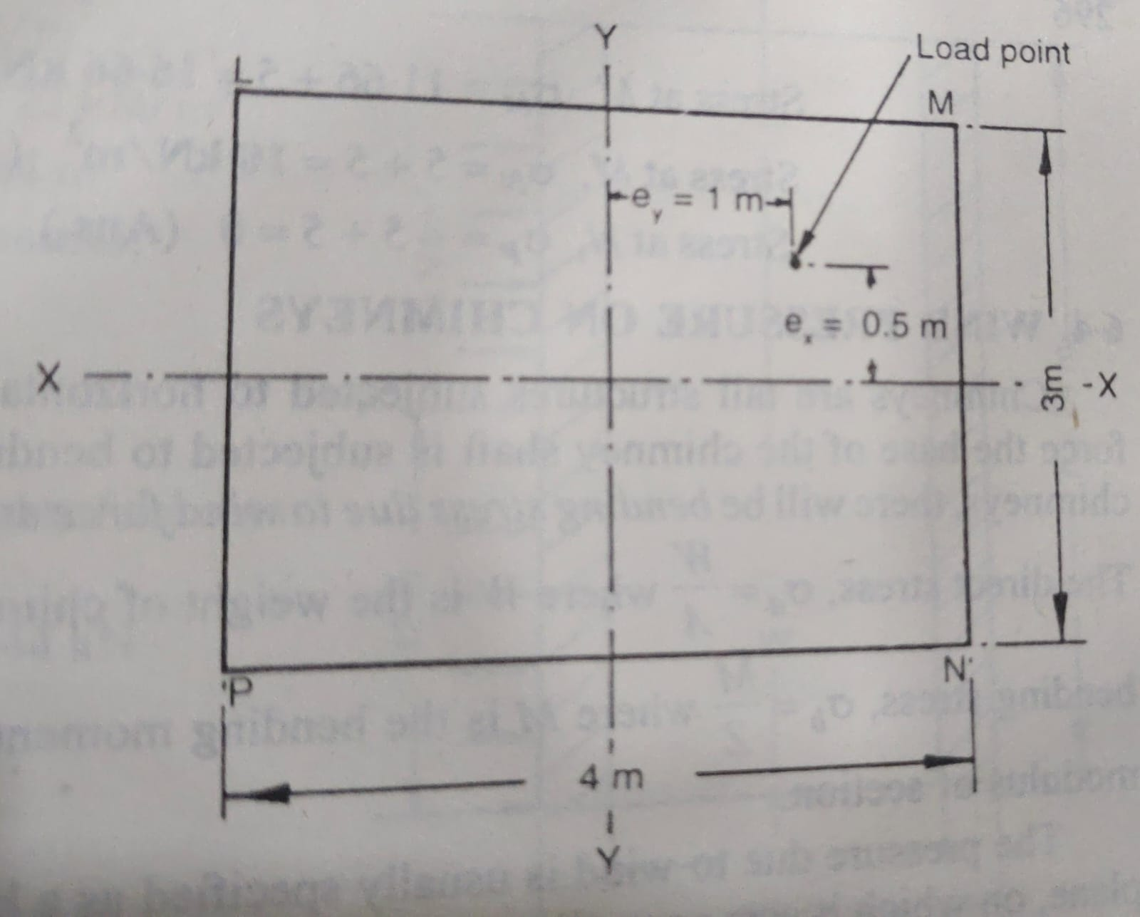 | L4 | CO4 | [8M]
 | OR
14 | A concrete dam of trapezoidal section 16m height and 4 m wide at the top and 8m wide at bottom. The water face is vertical and retaining water up to 14m. check the stability of dam. If the coefficient of friction is 0.7 and specific weight of concrete is 24 kN/m³. | L4 | CO4 | [8M]
15 | Derive the expressions for hoop stress and radial pressure at any point within the wall of a thick-walled cylinder subjected to internal and external pressure? | L3 | CO5 | [8M]
 | OR
16 | A Cylindrical shell 3m long which is closed at ends has a internal diameter of 1 m and wall thickness 15mm. calculate the circumferential stress and Longitudinal stress induced also find out change in length and change in diameter if the shell is subjected to Internal Pressure 1.5MN/m² | L4 | CO5 | [8M]
17 | A Beam of T section (Flange: 100mm* 20mm; Web: 150mm*10mm) is 2.5 Meters length and it is simply supported at ends. It carries a load of 3.2 kN inclined at 20⁰ to the vertical passing through centroid of section. If E= 200GN/m² determine the Maximum Tensile stress and Maximum Compressive stress  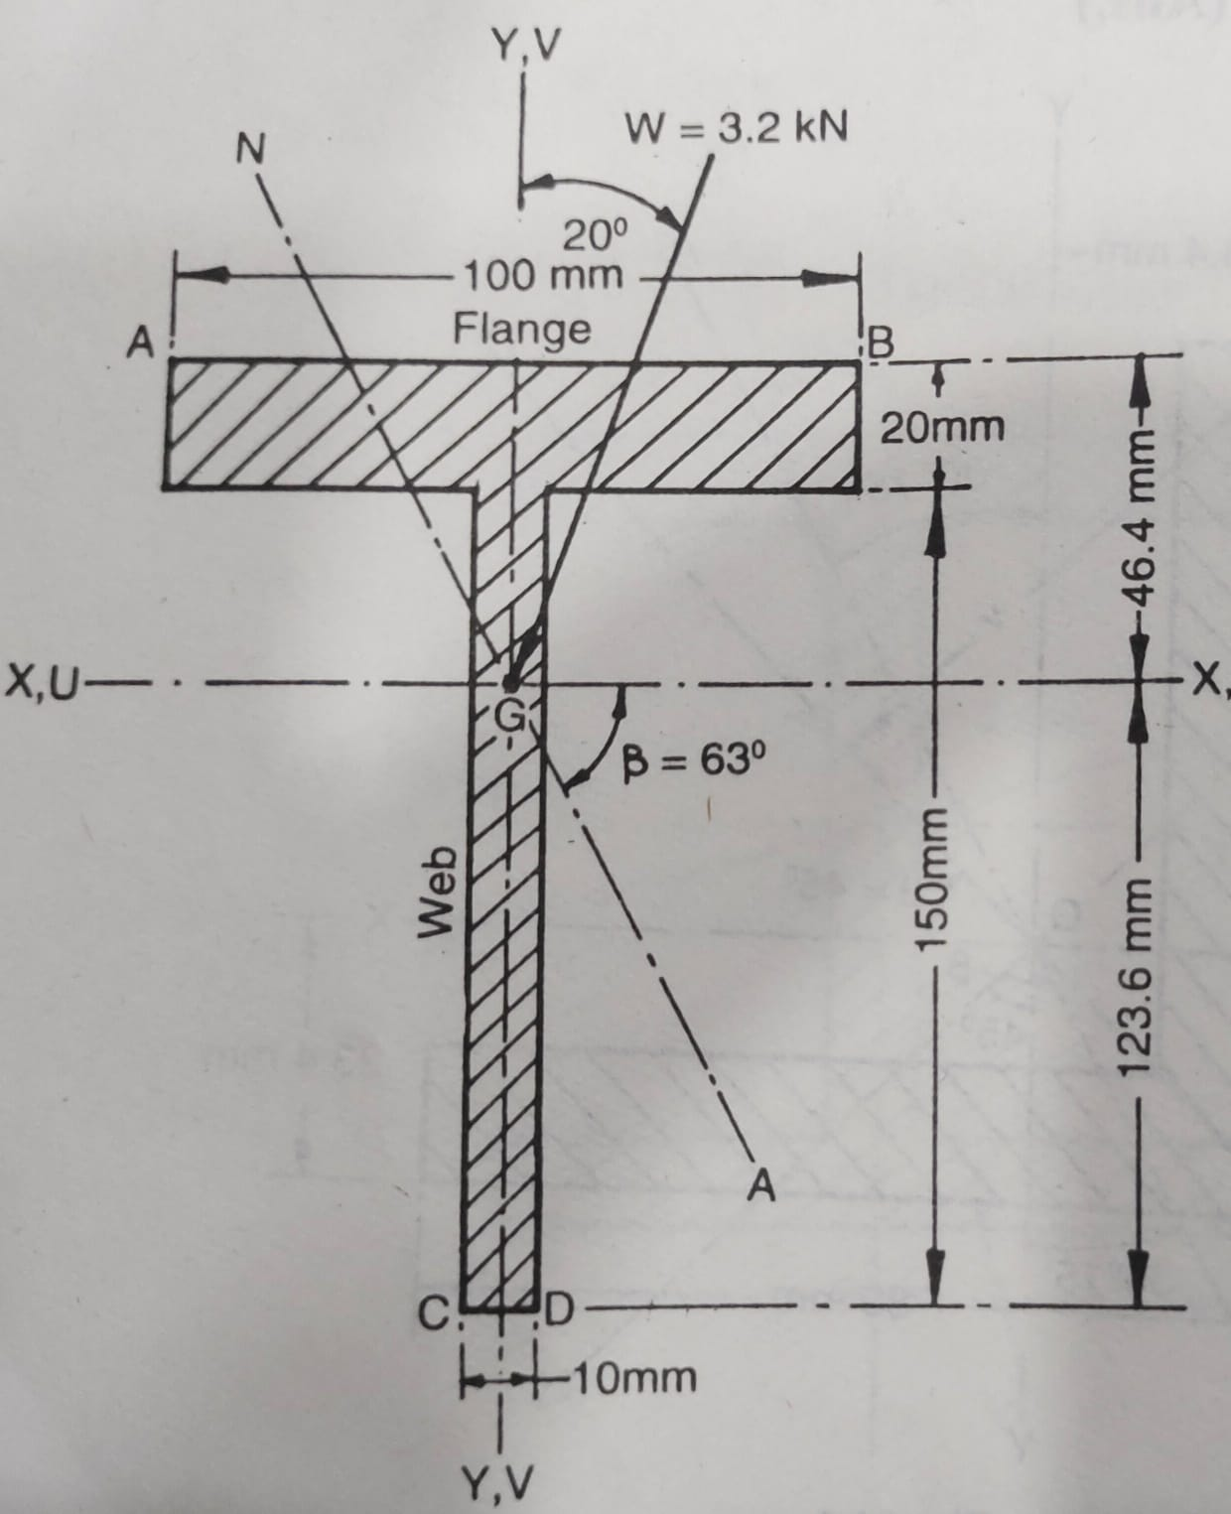 | L5 | CO6 | [8M]
 | OR
18 | Derive the equation for determining the location of the shear center of a C-section? | L3 | CO6 | [8M]

-- 00 -- 00 –

